Investment Summary
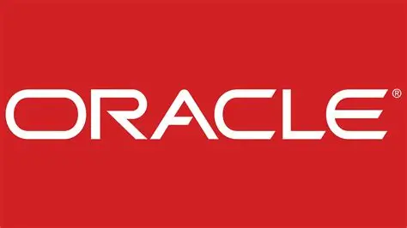
Nasdaq – Oracle Corporation Common Stock (ORCL)
Sector- Technology
1 Year Target Price - $287.50
Previous Close- $146.14
The cloud and licenses will able to continue due to increase in growth rate of cloud services including licenses and prices will also depend on the investment in Ampere Computing Holdings LLC and pending acquisition of Ampere by SoftBank Group Corp as and is long term in nature.
- The cloud services offering provides an integrated application and infrastructure which provides customers choose the best options applicable for their business needs.
- An increase in expenditure in Research and development through acquisition of businesses and technology, introduction of new products and improving of their current offerings.
There are some operational efficiencies faced by the company related to development of new products and issues related to timely launch of the products.
Risk Factors
- As Oracle is proving technology services various issues related to cloud system that is security, configuration errors can affect in working of system.
- Acquisitions which are not met for purpose for which was done which will result in operational and financial disrupts.
Valuations
Comparable analysis – Have Taken 5 peer companies
Company Name | P/E (Actual 2025)
Oracle | 33.21x
Advanced Micro Device | 65.39x
Texas Instrument Corporations | 39.15x
Salesforce Inc | 23.5x
Micron Technology Inc | 54.43x
GE Aerospace | 54.26x

Mean | 47.35x
Median | 54.26x

According to information and calculations done, the conclusion we want to give for valuations is that Oracle common stock is trading at discount as compared to other peer companies average P/E Ratio.
Recommendation
According to P/E ratio as well as target 1 year stock price Oracle is undervalued relative to the industry and is trading at discount so we can think of buying the stock.

